(Optional)

Intregrating VS-Code with AI Tools

There are many generative artificial intelligence (AI) tools in the market that assist you with coding. In this guide we will show you how to integrate them with Visual Studio Code. We do not have a preference for which one to use, and for this class almost any AI tool will be enough to handle coursework. Any differences between AI tools is more likely to be meaningful for more advanced use cases.

Emory currently has a partnership with Github Copilot, which offers free usage of its AI software to members of the Emory community, including students. Here we provide a guide on how to integrate it automatically with VS-Code. At the end, we briefly discuss integration of other tools, which follows very similar steps.

Github Copilot Integration:

- Sign up for a Github copilot account at https://github.com/features/copilot

Github-Copilot and Github are integrated, so if you already have a Github account you’re good to go. We recommend using your Emory email for complimentary access to the basic tier.

- Download the Github Copilot Extension. Go to the “Extensions” tab in the left panel and search for “Github Copilot” in the marketplace. Install the official one managed by “Github.com”.
- Once you install it, you will see a small “Chat” button emerge in the top section. Click on it.



- You will be prompted to go to a browser to validate the Gitub credentials. Once you do this, you should be ready to start working.
- (Optional but recommended) At the time of writing this guide, the default installation works without further configuration, but it has two distracting features: (i) it produces additional sounds when there is an error or a task was completed, and (ii) it gives an automatic code completion option that is sometimes difficult to work with if you want to do something outside the defaults. We suggest the following additional steps.

  - Go to settings icon in the “lower left” quadrant of VS-Code (this looks like a gear).

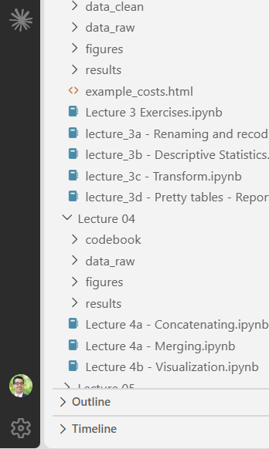

  - Search “volume” and set the corresponding value to zero.

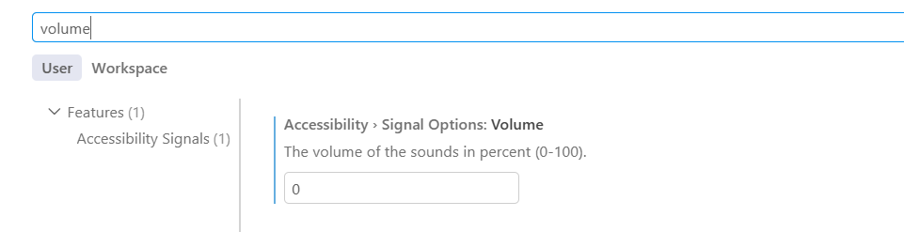
  - Search “Copilot:Enable” and set the value of “python” to false. Make sure to confirm your choice
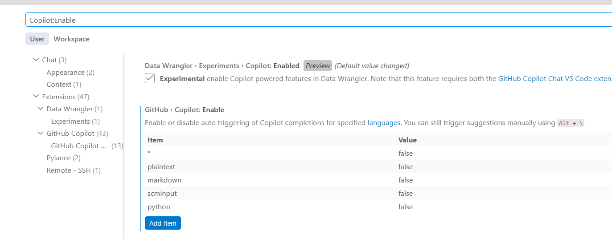
  - Search “lightbulb” and set it to “off”

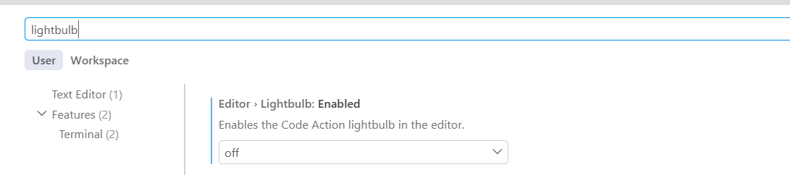

Integration with other AI-Tools:

The procedure with other AI tools like ChatGPT and Claude is very similar to that of Copilot: (1) Open an account, (2) Download the corresponding extension, (3) Log-in to the account.

The only difference with other AI tools is where the icon to access them is. For ChatGPT and Claude, it is either located in the left bar as a separate extension, or in the upper-right corner of the notebook as shown below:

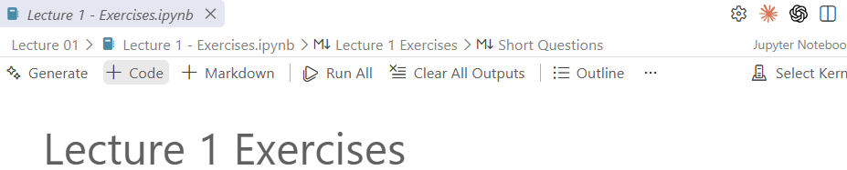

For advanced users: If you already have a Github account with a separate email that you prefer to manage your files, you can still open a separate account with your Emory email to get access to Github Copilot. You do not need to use the same account for Github Desktop and for the Github-Copilot-Extension we discuss here. They can be managed as two separate products.

